Name:

**MYP Student Workbook: What is the IB Middle Years Programme (IB MYP)?**

**Overview:** As part of the IB program in grades 9 and 10, students are known as MYP students. MYP is designed for **ALL** students so that they will be exposed to the IB philosophy and skills, regardless of whether they decide to enter the rigorous IB DP or IB CP program. IB MYP philosophy seeks to encourage learning through inquiry and student-based learning. Some of the components to the MYP curriculum include:

* 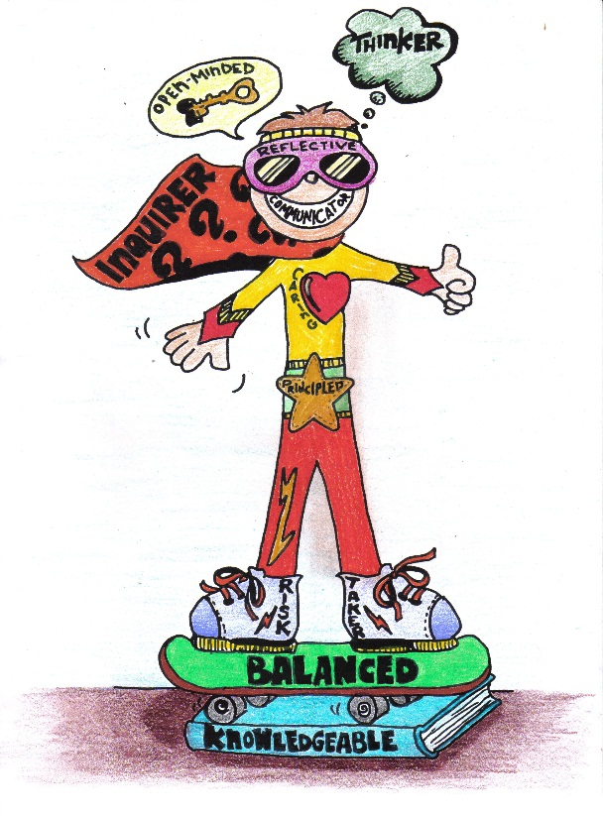**Internationalism**: Preparing students to live in a global world will mean encouraging all students to take a second language and asking students to participate in the service of others.
* **Real-World Relevance**: MYP asks that all instruction be relevant, real-world, inquiry based, and goal-oriented (see “**global contexts”**).
* **Student-Driven**: the MYP philosophy asks that students reflect on their growth as a learner throughout the program. A goal of the MYP program is that students reflect on their growth using the **“IB Learner Profile.”** Students also reflect on their learning process by creating a learning goal and reporting their journey in a **“Personal Project”** during their 10th grade year.
* **Best practices in education**: MYP asks that teachers design unit plans that incorporate inquiry questions, conceptual learning, and common IB rubrics on assessments. MYP asks that all unit plans and assessments be made accessible for other teachers, students, and parents and that they are submitted periodically for monitoring by the IB.

**APPROACHES TO LEARNING: ATL**

All curriculum is designed to assess growth in these skills, building complexity of tasks as students grow in the program and culminating in the Personal Project during grade 10.

* Social Skills
* Communication Skills
* Thinking Skills
* Research Skills
* Self-Management skills

**IB LEARNER PROFILE**

Students are encouraged to:

* Ask challenging questions
* Learn how to learn and then reflect on their own learning
* Develop a strong sense of their own identity and their culture
* Develop the ability to communicate with and understand people from other cultures

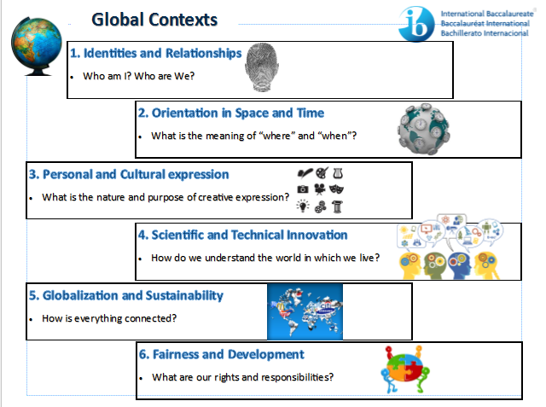

GLOBAL CONTEXTS

These are links to the “real world” application of all academic content. There are six designated MYP Global Contexts. There are used as different “lenses” with which to view the curriculum.

Learner Profile

The **LEARNER PROFILE** is a list of characteristics you should keep trying to develop as you move through middle school on to high school. Refer back to this page occasionally and see how you are succeeding. Teachers and staff might also notice your great work and nominate you as a student of the month based on learner profile attributes, so make sure to keep these in mind!

TASK # 1

**Directions:** Rank these according to your strengths (1-10) with 1 being your biggest strength and 10 the area for growth this year).

|  |  |  |
| --- | --- | --- |
| **Learner Attribute** | **Description** | **Ranking** |
| Caring | We care about others and the world around us and we are committed to having a positive impact on the world. |  |
| Open-Minded | We accept other points of view and other people’s beliefs and opinions. We understand that other people, even with ideas we don’t agree with, could also be right. |  |
| Balanced | We try to make sure our life and interests are given equal attention. |  |
| Principled | We are fair, honest, and just. |  |
| Inquirer | We are curious about the way the world works and ask intelligent questions in order to find out more. |  |
| Thinkers | We take the initiative in solving our own problems. |  |
| Knowledgeable | We develop our knowledge in more depth and with greater understanding. We apply our knowledge to global, local, and personal situations. |  |
| Communicator | We aim to educate the world with what we have learned, so that others can make a positive difference. |  |
| Reflective | We think about what we have achieved and the impact they have on the world around us/ |  |
| Risk-Taker | We are not afraid to take new challenges, to try new things or to make a positive difference in the world. |  |

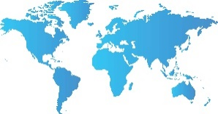

Describe what **Approaches to Learning** activity you used to practice each ATL skill. It could be through a class, an activity/club, a sport, or even at home or in the community. Rank these 1-5 with 1 being your biggest strength. What activities should you challenge yourself with this year to improve?

TASK # 2

**What skills does IB think a global citizen needs?**

|  |  |  |  |
| --- | --- | --- | --- |
| **ATL Skills** | **Examples of this Skill** | **Activities you do** | **Ranking** |
| Social | *How did you delegate responsibility, build consensus and make fair decisions (if in a group)?  *How did you listen to many perspectives or pieces of advice?  *How did you negotiate with others?  *How did you take responsibility for your actions?  * How did you build relationships? |  |  |
| Communication | *How did you communicate with a variety of audiences?  *How did you interpret and use non-verbal communication?  *How did you include intercultural understandings?  *How did you use a variety of forms of writing or speaking?  *How did you clarify misunderstandings? |  |  |
| Thinking | *How did you forecast possibilities and troubleshoot problems?  *Develop opposing arguments?  *Create original ideas and make unexpected connections?  *Design new improvements or solutions?  *Consider multiple alternatives?  *Make connections between various subject groups and disciplines? |  |  |
| Research | *How did you collect, record, and verify your information?  *How did you evaluate and select information?  *How did you understand and use technology systems effectively?  *How did you use a variety of sources and media networks?  *How did you compare, contrast, and draw connections between many sources? |  |  |
| Self-Management | *How did you keep an organized and logical system for recording your progress?  *Set goals that were both challenging and realistic?  *Bring necessary materials and supplies?  *Plan strategies for success and minimize obstacles?  *Meet deadlines? Persevere over obstacles? Reduce stress?  *How did you motivate yourself to get tasks done?  *How did you reflect on your learning and reflect on your mistakes to learn from them? |  |  |

My weakest skill is:

Something I could do to challenge myself to become better at this skill is:

What would be evidence that I have improved in this skill before the end of the year?

What would this skill look like in class? What would it look like outside of class?

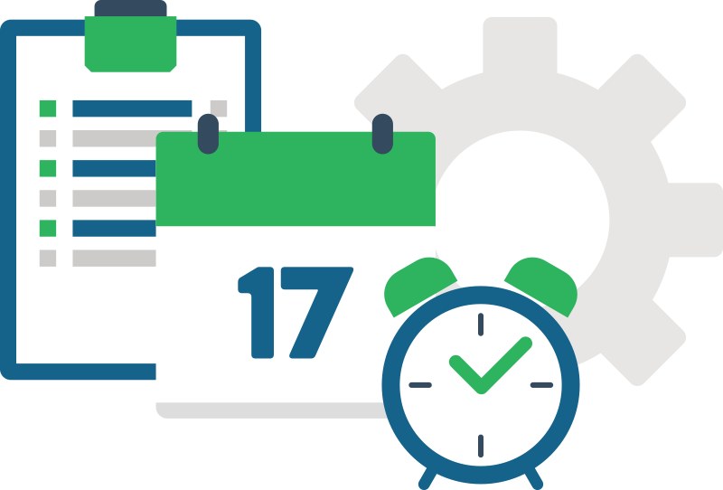

Every day, in every task we do, we are demonstrating one of the ATL skills or IB Learner Profile. Below is a list of things that Gordon did today. Most of the tasks and activities he has completed can be categorized as a skill. Which IB Learner Profile attribute fits what Gordon did today?

TASK # 3

|  |  |  |
| --- | --- | --- |
| **Task/Activity** | **Learner Profile** | **ATL Skills** |
| Gordon went to the store to buy some pencils and folders for school. | **Example:**  **Knowledgeable about what is needed for class.** | **Example:**  **Organize Materials** |
| Gordon was working with a group of people when he noticed a girl was upset. He made her feel better by asking her to join their group. |  |  |
| After-school, Gordon and a group of his friends planned to go outside and pick up the garbage around the school as a part of a club they belong to. When only two friends showed up, they had to adjust their goals for the day. |  |  |
| The teacher asked Gordon if he could lead the class in singing “The Star Spangled Banner”. Gordon said he was very shy and was afraid to stand up in front of large groups of people so he refused to leave the class. However, he did stand up to sing with the group. Afterwards, he thought about how he could hand the situation differently next time. |  |  |
| Gordon has a Science Fair Project due about space. He found an astronaut to interview and asked him many questions about space exploration. |  |  |

**What is Global Context?**

TASK # 4



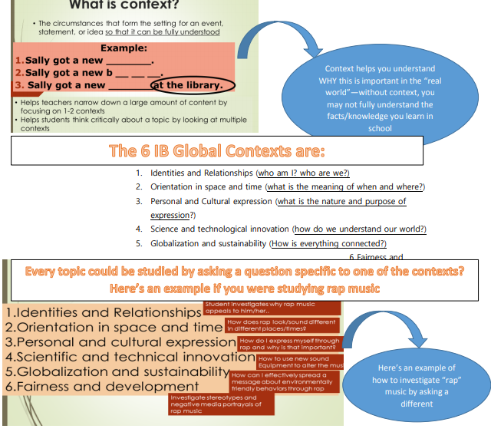

Now you and a partner choose a topic you would like to learn about:

Write **6 RESEARCH QUESTIONS** that you could use to investigate it through different global contexts, like in the example above.

1. ­_______________________________________________________________________________________________________
2. _______________________________________________________________________________________________________
3. _______________________________________________________________________________________________________
4. _______________________________________________________________________________________________________
5. _______________________________________________________________________________________________________
6. _______________________________________________________________________________________________________

What topic are you studying now or will you be studying next in your Individuals and Societies class?

What Global Contexts might you be able to apply to this topic?

